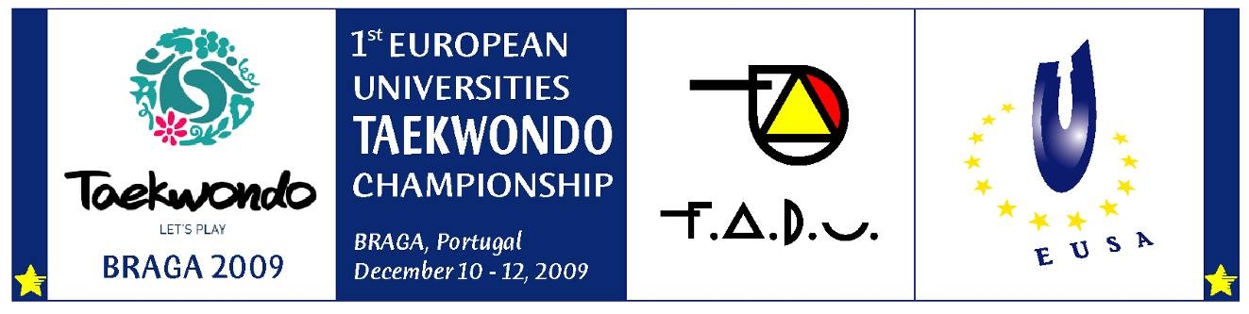

QUANTITATIVE ENTRY FORM

Country:
University:
Competition: | □ Women □ Men
Arrival Date: | □ Car □ Train □ Airplane
Departure Date: | □ Car □ Train □ Airplane

DELEGATION |   MEN | WOMEN | TOTAL | Participation Fee  € 50,- person/day
OFFICIALS
ATHLETES
REFEREE | XX | XX | XX | XX

TOTAL

50% of the participation fees shall be paid 1 month before the championship (together with quantitative entry); the balance shall be paid upon arrival. The fees have to be transferred without any bank fees to the following account:

BANK: Caixa Geral de Depositos
ADRESS: Campus de Azurem, 4800-058 Guimaraes – Portugal
SWIFT: CGDIPTPL
IBAN: PT50 0035 0130 0000 0655 5300 7
FOR: Servicos de Accao Social da Universidade do Minho
STATING: Campeonato Europeu Universitario de Taekwondo

Signed by:

........................................................... /..........................................................
(Name / Position / Function)
........................................................... /..........................................................
Date, signature and stamp

Deadline: OCTOBER 10, 2009 Entry to be sent to the Organising Committee

